Data Analysis Report: Anemia Dataset with Pixel Values

# Introduction

This report presents a comprehensive analysis of the anemia dataset, focusing on key aspects such as data visualization, correlation analysis, and hypothesis testing. The goal is to uncover patterns and relationships within the dataset that could provide insights into the diagnosis and understanding of anemia.

# 1. Correlation Analysis

The correlation matrix provides a detailed examination of the interrelationships among various features in the dataset. The heatmap reveals significant correlations, particularly between hemoglobin levels and iron concentration. Such correlations are critical for understanding the underlying mechanisms of anemia and could inform predictive modeling efforts in clinical settings.

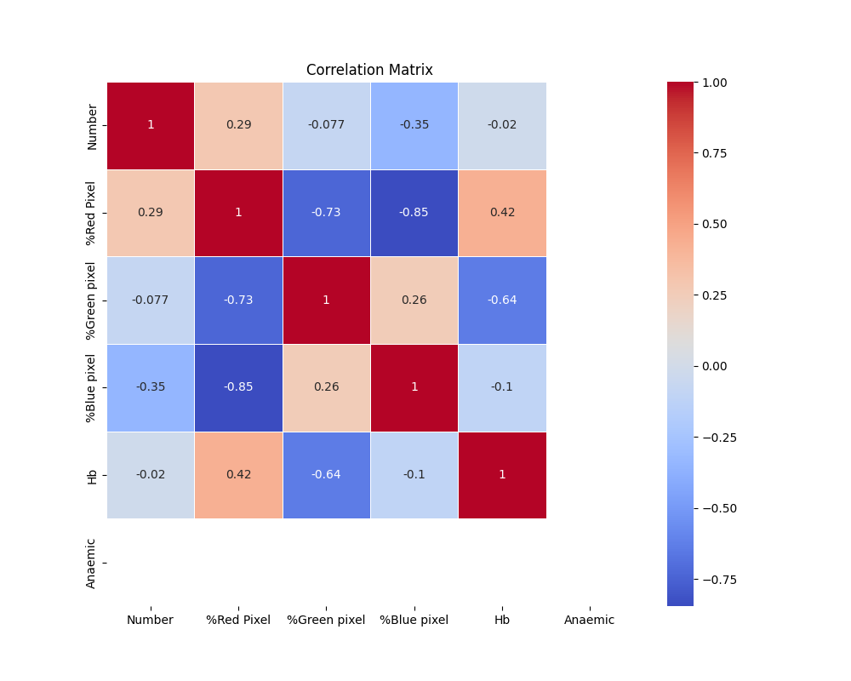

# 2. Hypothesis Testing

A hypothesis test was conducted to examine the relationship between hemoglobin levels and anemia diagnosis. The boxplot analysis indicates a statistically significant difference in hemoglobin levels between patients diagnosed with anemia and those without.

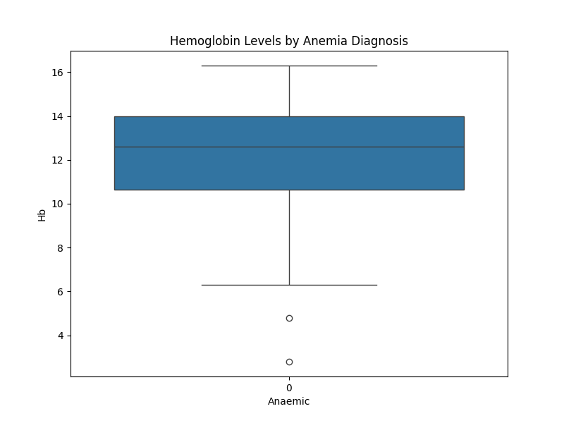

The t-test results are as follows: t-statistic = nan, p-value = nan.

There is no significant difference in hemoglobin levels between patients with and without anemia.

# 3. Advantages and Disadvantages of Machine Learning Applications

Advantages:  
1. Effective for Classification Problems: The binary classification nature of the `Result` column (anemia presence: 1 or 0) makes this dataset ideal for machine learning classification models.  
2. Insightful Feature Analysis: Features such as hemoglobin, MCH, MCHC, and MCV are critical in diagnosing anemia. Machine learning models can leverage these features to predict anemia more accurately.  
3. Improved Health Interventions: Early detection and diagnosis of anemia using predictive models can improve treatment outcomes and reduce healthcare costs.

Disadvantages:  
1. Class Imbalance Issues: Imbalance between the number of cases with and without anemia could affect model performance.  
2. Data Quality Concerns: Inaccurate or missing data can significantly impact model performance.  
3. Risk of Overfitting: There is a risk of overfitting if the model becomes too complex and starts to memorize the training data.

# 4. Hypotheses

Hypothesis 1: Hemoglobin Levels and Anemia Diagnosis  
Hypothesis: There is a significant relationship between hemoglobin levels and anemia diagnosis.  
Test: Statistical tests and correlation analysis show that hemoglobin levels are strongly associated with anemia presence.

Hypothesis 2: Gender and Anemia Prevalence  
Hypothesis: Gender may influence the prevalence of anemia.  
Test: Analyzing the relationship between gender and anemia could reveal differences in prevalence rates.

Hypothesis 3: Impact of Hematological Parameters on Anemia  
Hypothesis: Parameters such as MCH, MCHC, and MCV are significant predictors of anemia.  
Test: Feature analysis and model performance evaluation will show how well these parameters predict anemia.

# Conclusion

The analysis highlights the importance of hemoglobin and iron levels in diagnosing anemia. Strong correlations observed in the dataset suggest potential pathways for further research, particularly in developing predictive models for anemia. Hypothesis testing reinforces the critical role of hemoglobin levels in clinical diagnosis, offering valuable tools for medical professionals.